# Package Installation Guide

## Step by step guide to install and update packages

This section will detail the system requirements and UiPath packages to be available in the system to ensure that it executes the codes correctly. Follow the steps to install the package in UiPath studio:

**Step 1.** Click on Manage Packages.

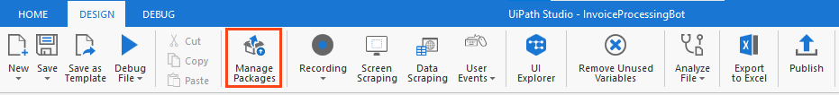

Figure 1 Manage Packages Ribbon Bar

**Step 2.** Search the package according to the project requirement.

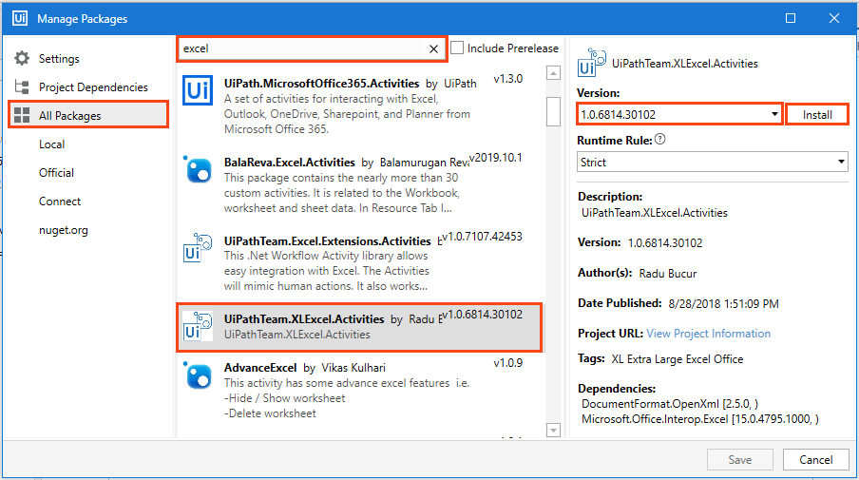

Figure 2 Package Installation

**Step 3:** Select the package and the version to be installed.

**Step 4:** Save the packages by clicking on the “Save” button.

## Viewing list of installed Packages

To view the packages used in code, right-click on the “Dependencies” option of “Project” panel and select “Manage” option (refer Figure 3).

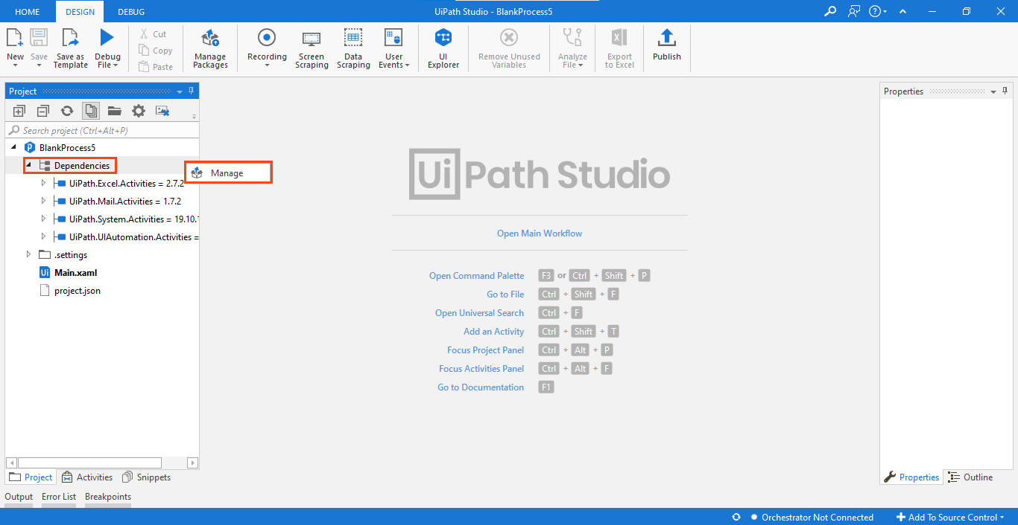

Figure 3 Installed Packages List

Note: For the codes which involve browser usage, the browser should have its extension installed. You can install an extension from the 'Tools' section of UiPath Studio.

# Basic Projects

## Email Auto-responder Robot

The code comprises of six packages (refer Table 3) and they must be installed in the studio for the Robot to execute the task successfully.

* Microsoft.Activities.Extensions
* UiPath.Excel.Activities
* UiPath.Mail.Activities
* UiPath.System.Activities
* UiPath.UiAutomation.Activities
* UiPath.Web.Activities

Table 3 List of packages used in 'Email Autoresponder Robot'

The above-listed packages used can be viewed on the left side of the "Project" panel tab (refer Figure 8).

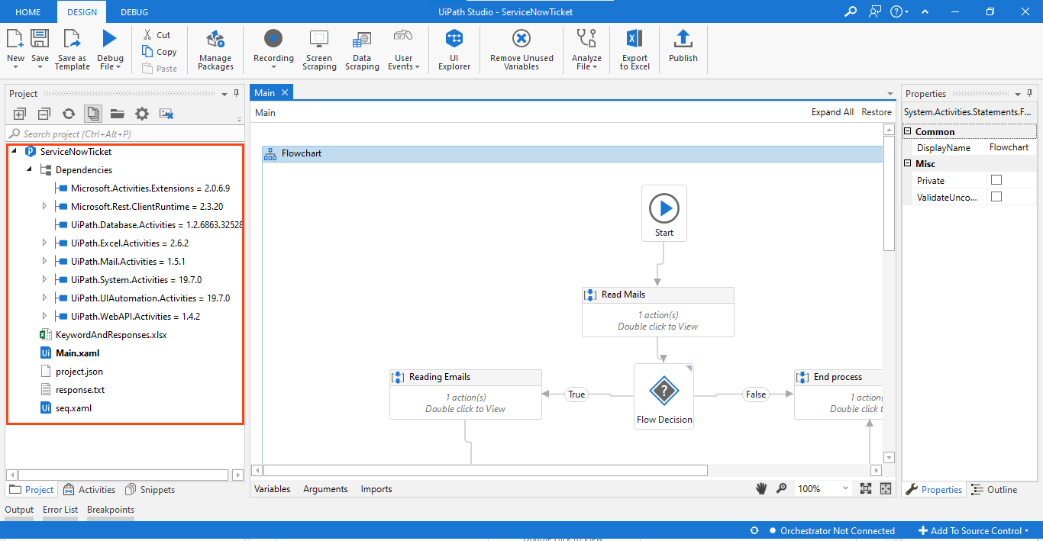

Figure 8. List of Packages used in '

Email Autoresponder Robot.'

Right-click on "Dependencies" and select "Manage" to view all project dependencies (refer figure 9).

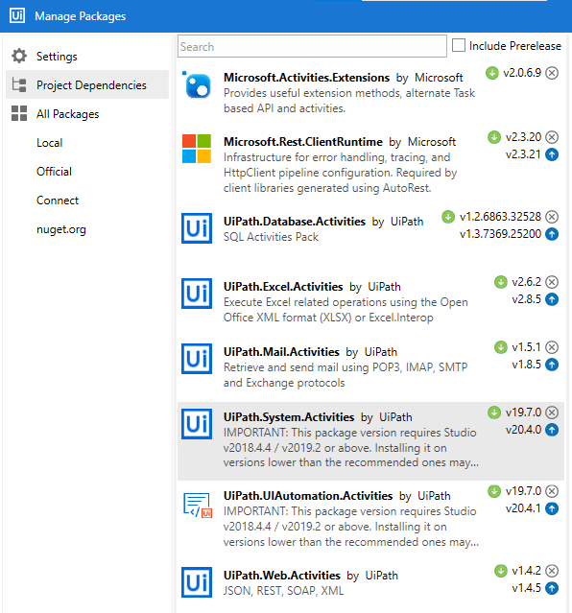

Figure 9 Project Dependencies in ‘Respond to Email’

**Note: If a package appears in 'Red' it indicates a problem. To resolve it, right-click on the package name and click resolve/update.**

**Prerequisite:**

Outlook application should be configured on your device.

‘**Keyword&Responses.xlsx**’ file is available in the project folder.

The subject of the received email should be ‘**HelpDesk**’ and the body of the email should contain the phrase mentioned inside the keyword column of ‘**Keyword&Responses.xlsx**’ file.

Note:- The Robot will send the response on the same Email Id from which the email was received.

## Process Flow Chart

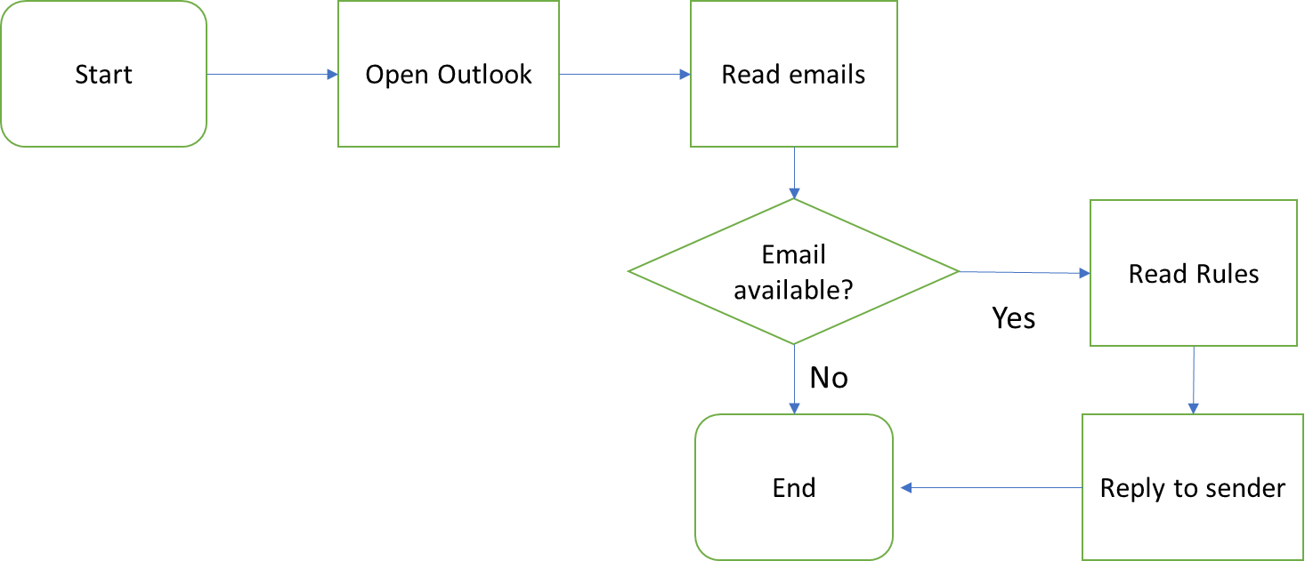

## Applications to be used



Based on the scope, applications to be used for Email Auto-responder Robot are:

**1. UiPath Studio:** Used to create the Robot.

**2. MS Excel:** Used to read rules for the Robot.

**3. MS Outlook:** Used to read mail and send response to sender.

## Process steps

**Project Overview:** This project aims to build a robot that automatically responds to emails. The robot works like a helpdesk assistant. It reads the emails from a specific email id and responds to it using a pre-defined email template. The response template is specified in the ‘Keywords&Responses.xlsx’ file. The emails identified are based upon the keywords mentioned in the email. These keywords are already stored in an excel file which the robot refers to while responding. The Robot will read the email and filter them based upon the ‘subject’. It will then further read the email and look for a phrase/keyword in the email body and will match it with the one mentioned in the ‘Keywords&Responses.xlsx’ file. The robot will send an email response to the sender by copying the text from the excel file.

## Steps to make an Email Auto-responder Robot:

**Step 1:** The Robot opens the email application called Outlook.

**Step 2:** It reads the email subject of all the unread emails.

**Step 3:** It then checks if the email subjectis **“Helpdesk”**.

**Step 4:** If it is **“Helpdesk”** then it reads the email body.

**Step 5:** Checks if the email body has keywords which are mentioned in the key column of ‘Keyword&Responses.xlsx’ file.

**Step 6:** If the key is found in email body then it replies with the associated value of the “value column” line to the email address from which the email was received.